Q1. Create a student table with the student id, name, and marks as attributes where the student id is the primary key.
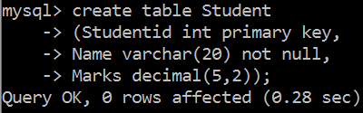
Query:

Q2. Insert the details of a new student in the above table.
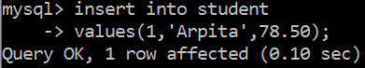
Query:

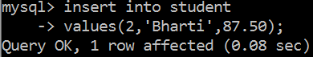

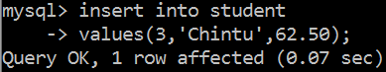

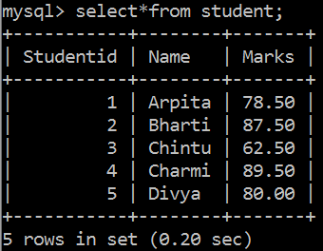
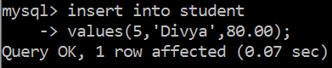
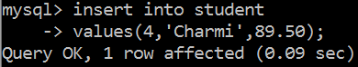

Q3. Delete the details of a student in the above table.
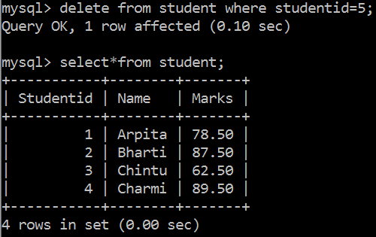
Query:

Q4. Use the select command to get the details of the students with marks more than 80.
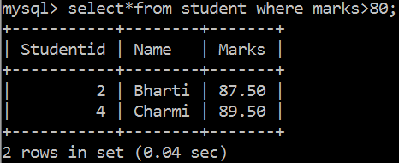
Query:

Q5. Find the min, max, sum, and average of the marks in a student marks table.
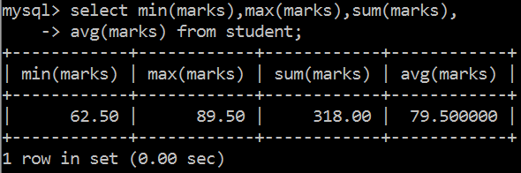
Query:

Q6. Write a SQL query to order the (student ID, marks) table in descending order of the marks.
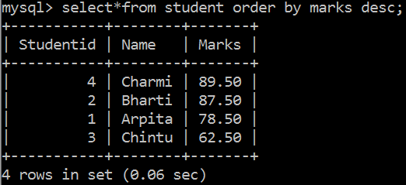
Query:

Q7. Write a SQL query to display the marks without decimal places, display the reminder after diving marks by 3 and display the square of marks.
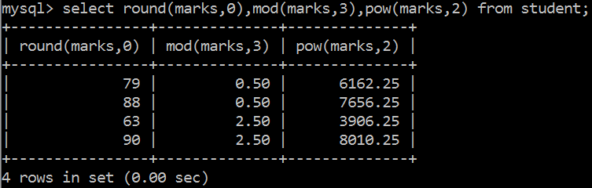
Query:

Q8. Write a SQL query to display names into capital letters, small letters, display first 3 letters of name, display last 3 letters of name, display the position the letter A in name.
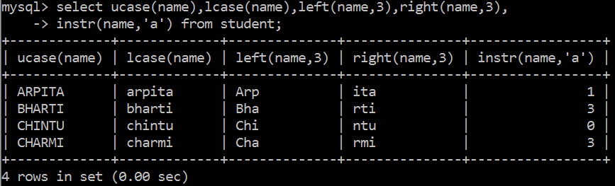
Query:

Q9. Remove extra spaces from left, right and both sidesfrom the text – “ Informatics Practices Class XII ”.
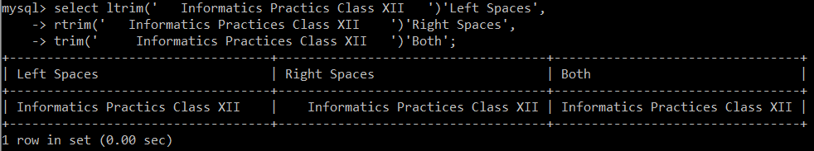
Query:

Q10. Display today’s date in “Date/Month/Year” format.
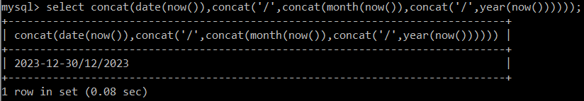
Query:

Q11. Display dayname, monthname, day, dayname, day of month, day of year for today’s date.
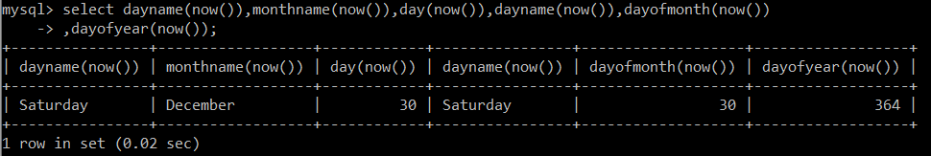
Query:

COMPLETED

